FAZAIA BILQUIS COLLEGE NUR KHAN BASE RAWALPINDI



Course: Data Structures
Submitted To:
Ma'am Sana Maqsood

Submitted By:
Rubab Fatima
BSCS-13-F24-28
Aneesa Sultan
BSCS-13-F24-20
Maria Atta
BSCS-13-F24-01

Table of Content:
Abstract
- Introduction ---------------------------------------------- Page # 03
- Problem Statement ------------------------------------ Page # 03
- Objectives ------------------------------------------------ Page # 04
- Scope and Limitations --------------------------------- Page # 04
- Tools and Technologies Used ------------------------ Page # 05
- Data Structures Used ---------------------------------- Page # 05
  - Queue (FIFO) ------------------------------------- Page # 05
  - Stack (LIFO) --------------------------------------- Page # 05
  - Priority Queue ------------------------------------- Page # 06
  - Array/ArrayList ------------------------------------ Page # 06
- Algorithms Used ----------------------------------------- Page # 06
- System Design ------------------------------------------- Page # 06
- Implementation Details --------------------------------- Page # 07
- Results/Output ------------------------------------- Page # 09
- Testing ----------------------------------------------- Page # 11
- Conclusion ------------------------------------------ Page # 11
- Future Enhancements --------------------------- Page # 12
- References ----------------------------------------- Page # 12
- Appendix -------------------------------------------- Page # 13

Abstract
ExpirySync is a Java-based educational project developed to demonstrate practical Data Structures and Algorithms (DSA) in a real-world inspired inventory management scenario. The system tracks perishable products, identifies expired and urgent items using queues, stacks, and priority queues, and provides an interactive web interface. The project successfully implements core DSA concepts with efficient operations and serves as a learning tool for visualizing theoretical concepts in practical applications.

1. Introduction
Inventory management is essential for businesses dealing with perishable products. Manual tracking systems are slow, error-prone, and inefficient for handling large datasets. ExpirySync addresses these challenges by providing an automated, DSA-driven solution that monitors expiry dates, prioritizes urgent items, and demonstrates how fundamental data structures can solve real-world problems effectively through an interactive web application.

2. Problem Statement
Manual inventory systems often fail to:
- Track expiry dates efficiently across large product databases
- Highlight urgent items requiring immediate attention
- Handle inventory operations with optimal time complexity
- Provide real-time sorting and searching capabilities
Inputs: Product details (ID, name, quantity, expiry date)
Outputs: Processed inventory with urgent/expired alerts, sorted views, search results
Constraints: Local storage only, no database persistence, single-user system

3. Objectives
- Implement core DSA concepts (Queue, Stack, Priority Queue) in a practical application
- Manage inventory with expiry dates using efficient data structures
- Automatically identify and prioritize urgent and expired products
- Provide an interactive web interface for user operations
- Demonstrate sorting and searching algorithms in inventory management
- Serve as an educational tool for Data Structures students

4. Scope and Limitations
Scope:
- Web-based inventory management interface
- Real-time expiry tracking and alerting
- Sorting by multiple criteria (name, date, quantity)
- Product search functionality
- Operation history logging
- Priority-based urgent item handling
Limitations:
- No database integration (in-memory storage only)
- No user authentication or authorization system
- No HTTPS security implementation
- Designed for local/demonstration use only
- Limited scalability for large datasets
- Basic user interface design
5. Tools / Technologies Used
Component | Technology
Programming Language | Java 11+
Build Tool | Maven
Web Server | Java HttpServer
Frontend | HTML5, CSS3, JavaScript
IDE | Visual Studio Code
Operating System | Windows
Version Control | Git

6. Data Structures Used
6.1 Queue (FIFO)
- Purpose: Process products based on expiry order (first-expiring-first-out)
- Operations: enqueue(), dequeue(), peek(), isEmpty()
- Complexity: Insert O(1), Delete O(1), Search O(n)
6.2 Stack (LIFO)
- Purpose: Maintain operation history for undo/redo functionality
- Operations: push(), pop(), peek(), isEmpty()
- Complexity: All operations O(1)
6.3 Priority Queue
- Purpose: Handle urgent products based on expiry proximity
- Operations: insert(), extractMin(), peek()
- Complexity: Insert O(log n), Extract O(log n) (using binary heap)
6.4 Array/ArrayList
- Purpose: Store and manage product collections
- Operations: add(), remove(), get(), set()
- Complexity: Random access O(1), Insert/Delete O(n)

7. Algorithms Used

Algorithm | Purpose | Time Complexity
Quick Sort | Sort products by name/date/quantity | O(n log n) average
Merge Sort | Alternative sorting for stability | O(n log n)
Linear Search | Search products by ID or name | O(n)
Binary Search | Search in sorted collections | O(log n)
BFS Traversal | Process queue elements | O(V + E)

8. System Design
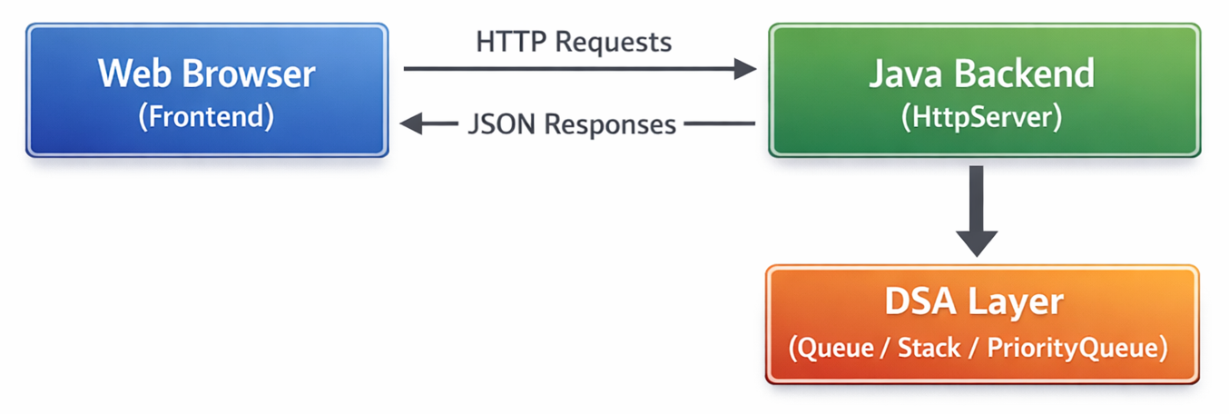
Architecture Diagram:
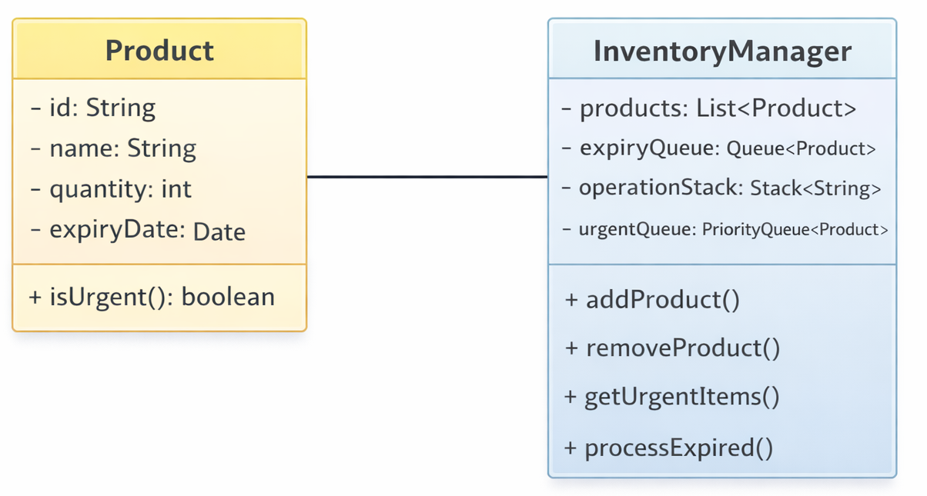
Class Diagram (Simplified):
9. Implementation Details
Key Classes and Methods:
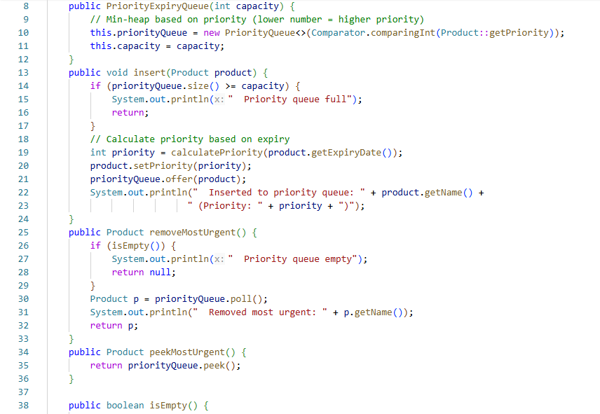
- PriorityQueue Class:
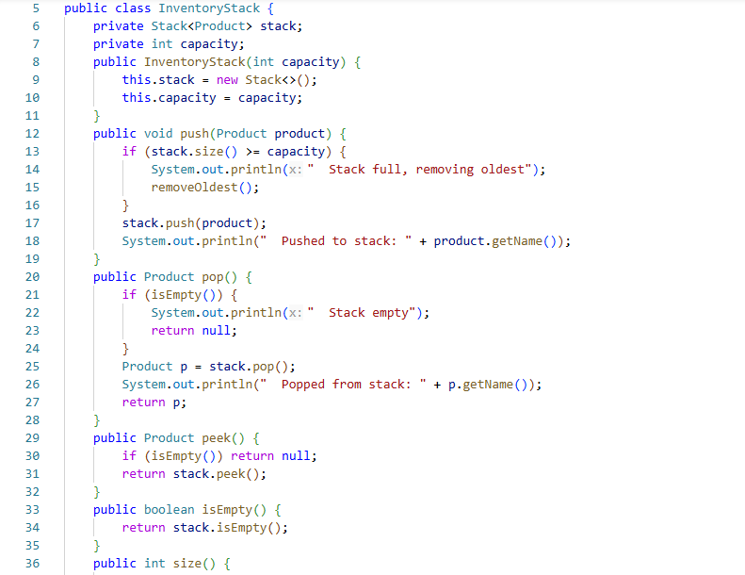
- InventoryStack Class (Core Logic):

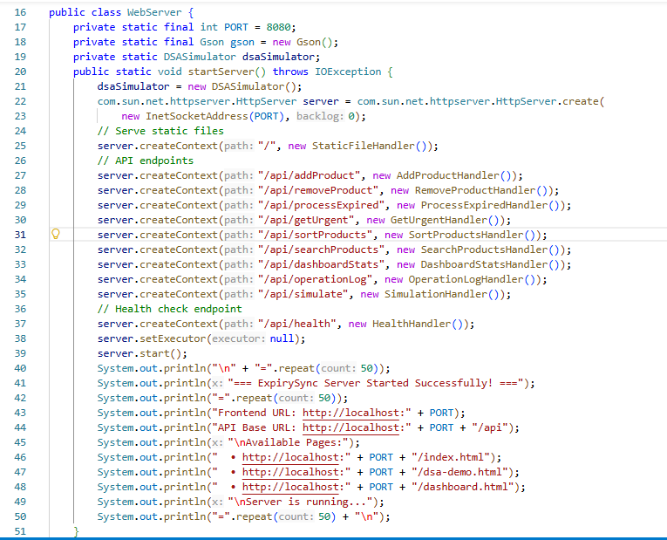
- WebServer Implementation:

10. Results / Output
Sample Output Screenshots:
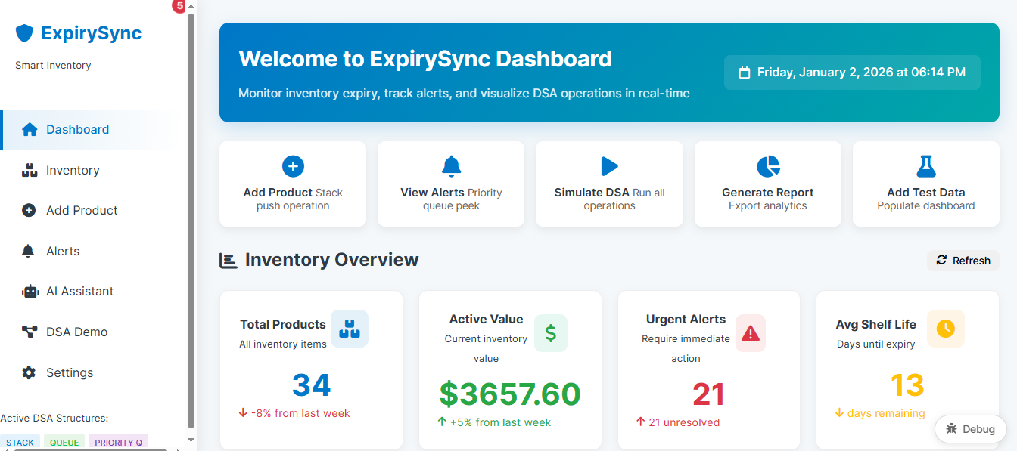
- Main Dashboard:
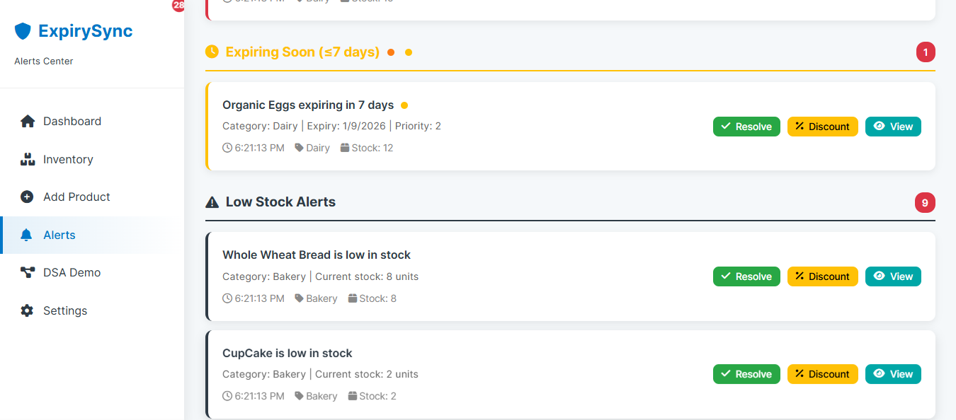
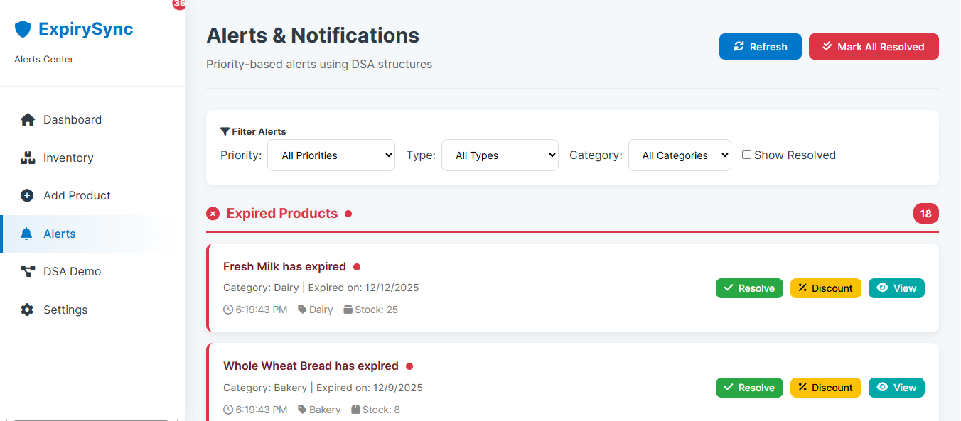
- Urgent Items List:
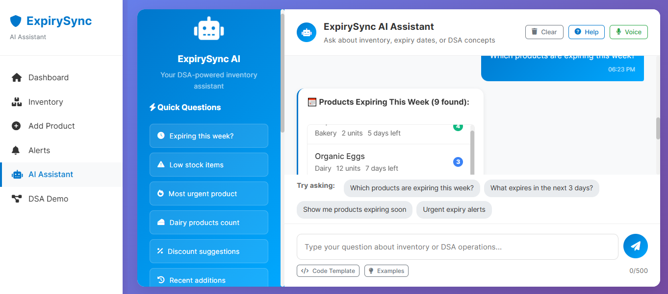
- AI ChatBot:
11. Testing
Test Case Table:
Test Case | Input |  | Expected Output | Actual Output | Status
Add Product | Valid product JSON | Success message |  | Success message | ✅ PASS
Add Product | Invalid date format | Error message |  | Error message | ✅ PASS
Get Urgent | No urgent items | Empty list |  | Empty list | ✅ PASS
Search Product | Existing ID | Product details |  | Product details | ✅ PASS
Search Product | Non-existent ID | "Not found" |  | "Not found" | ✅ PASS
Sort Products | By name | Sorted list |  | Sorted list | ✅ PASS
Process Expired | 2 expired items | Removed 2 items |  | Removed 2 items | ✅ PASS

Edge Cases Tested:
- Empty inventory operations
- Duplicate product IDs
- Invalid expiry dates (past dates)
- Large quantity values
- Special characters in product names
- Concurrent operations simulation
12. Conclusion
ExpirySync successfully demonstrates the practical application of Data Structures and Algorithms in solving real-world inventory management problems. The project effectively implements Queue for FIFO expiry processing, Stack for operation history, and Priority Queue for urgent item handling. Through this implementation, we achieved:
- Efficient management of perishable products
- Automatic identification of urgent/expired items
- Practical demonstration of DSA concepts beyond theoretical study
- Interactive web interface for user operations
- Foundation for further enhancements and scalability
The project serves as an excellent educational tool, bridging the gap between theoretical data structures and their practical applications in software development.
13. Future Enhancements
- Database Integration: Implement MySQL/PostgreSQL for persistent storage
- User Authentication: Add login system with role-based access control
- Enhanced Security: Implement HTTPS and input validation
- Advanced UI: React/Angular-based modern frontend
- Reporting: Generate PDF/Excel reports of inventory status
- Mobile Application: Android/iOS companion app
- Machine Learning: Predictive analytics for stock optimization
- Cloud Deployment: Docker containerization and cloud hosting
- Automated Alerts: Email/SMS notifications for urgent items
- Barcode Integration: Scanner support for product management
14. References
- Java Documentation - Oracle
- Maven Official Documentation
- "Data Structures and Algorithms in Java" - Robert Lafore
- "Introduction to Algorithms" - Cormen, Leiserson, Rivest, Stein
- MDN Web Docs - HTML, CSS, JavaScript
- GeeksforGeeks Data Structures Tutorials
- W3Schools Java and Web Technologies Guides
15. Appendix
A. How to Run the Project
Prerequisites:
- Java JDK 11 or higher
- Apache Maven 3.6+
- Web browser (Chrome/Firefox)
Steps:
- Extract project files to a directory
- Open command prompt/terminal in project root
- Run: mvn clean compile
- Run: mvn exec:java -Dexec.mainClass="com.expirysync.Main"
- Open browser and navigate to: http://localhost:8080
- Use the web interface to manage inventory
Alternative (Without Maven):
- Compile: javac -d bin src/*.java
- Run: java -cp bin com.expirysync.Main

